Gleann Beag

The Phillips Family zero-carbon house in Downend

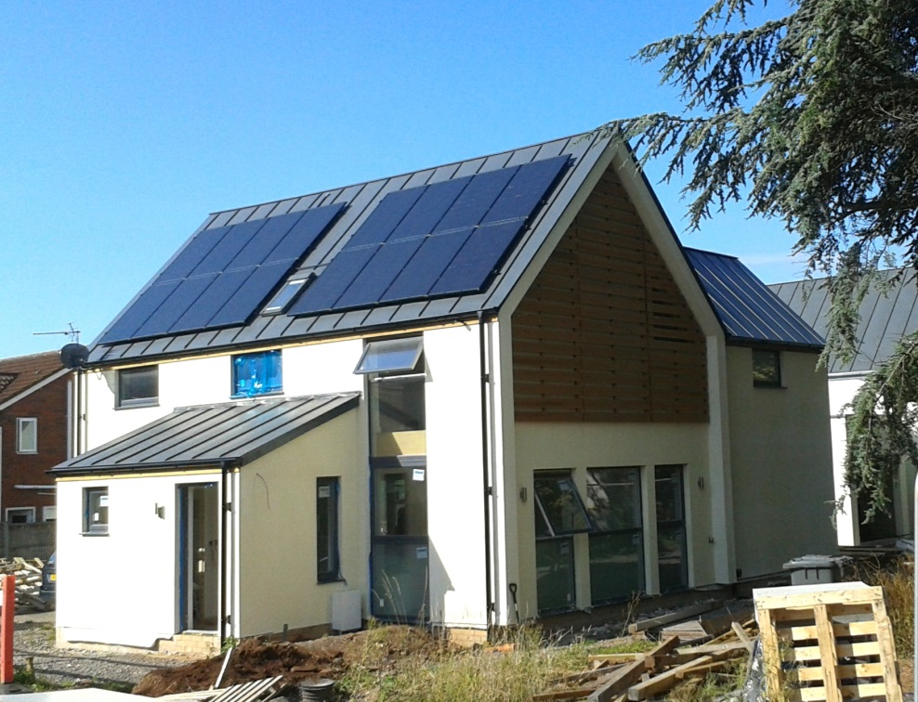

Main Features

* 1528sqft (142sqm) total living area
* Timberframe construction
* Highly thermally efficient
* Air tight with Mechanical Ventilation and Heat Recovery (MVHR)
* Lightweight steel roof covering
* Wet downstairs underfloor heating with conventional radiators upstairs
* Three full bathrooms
* Thermal mass and acoustic isolation to first floor
* Aluminium/timber composite triple-glazed argon-filled windows

Why?

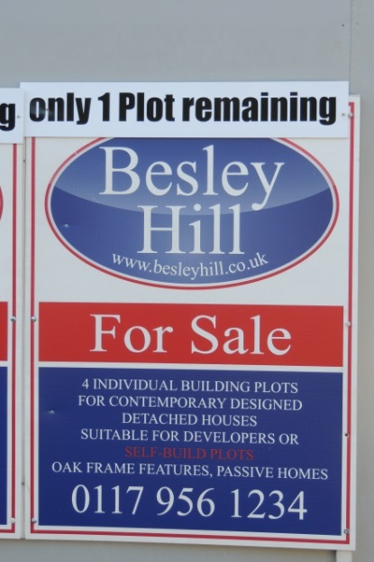Having lived in Bristol since late 2009, we have become settled. In particular, the Girls have grown up with new friends and progressed well at school. Hence, while living in quarters we considered how best to transition to living, and affording, our own house. Our preference was to self-build a thermally efficient home and in anticipation Jim started to study with the Centre for Alternative Technology. However, finding suitable land in the right place for the right price is a challenge that initially thwarted us. We began to look for older jaded properties to buy at below market price to eco-refurbish, but were beaten 3 times by others who needed to spend less for their own ambitions. Hence, by the summer of 2012 we were losing heart when we spotted this buried in an overgrown hedge in Downend (only without the ‘1 Plot remaining’ header). We immediately went to the Estate Agent and put our names down on Plot 2. The contractor arranging the transition from existing property to 4 building plots needed at least 3 committed self-builders on board before he could proceed, and it was a complex contract that needed to be in place in order for money to be transferred, a process that was not complete until April 13. However, by Aug 13, we were ready to start.

Figure 1: The Sign

What?

The Plot came with added benefits in the shape of detailed planning permission, drainage, service trenches, fencing, a new public path at the front, roadway material to service plots 2-4 and dropped curbs for Plots 1 and 2 (with direct road access to Church Lane).



Site Road

Church Lane

Plot 1

Plot 2

Plot 4

Plot 3

Figure 2: Site Plan

These additional features gave us a head start on the complex business of self-building, and removed some of the fear barriers. However, it did tie us to a design as planning permission had eluded previous attempts for 12 years and, hence, we had to work with the design as was, rather than try to adapt it and risk losing permission. Nevertheless, we worked with the Architect and made the following design changes:

* Altering the ‘lean to’ to improve in-out flow, adding a shower to the cloakroom to create a full downstairs bathroom for ageing relatives (and growing children) plus a wardrobe close to the front door.
* Taking a bite out of the main 19’x32’ room to create a utility room (to hide away the noisy washing machine!).
* Swapping the en-suite and main bathroom and then adding a walk-through wardrobe to get to the en-suite from the master bedroom.
* Adding a ‘bulkhead’ loft to give storage space and also a location for some of the systems, plus almost incidentally creating alcoves in 3 bedrooms for built-in wardrobes.
* Increasing the thermal mass and acoustic isolation on the first floor.
* Increasing the thickness of the wall insulation from 140mm to 180mm and creating a service void at the same time.
* Removing a proposed oak frame which added £30K to cost, but nothing to structural strength.
* Adding the base for a future garage/workshop build.



Figure : Ground Floor

How?

It would have been best to have used a single project manager or prime builder to have off-loaded all the detailed management activities to, but that would also have cost an additional ~£25K which we could not have afforded without significant, potentially catastrophic, reduction in the quality of the final product. Hence, we had no choice but to act as our own project managers with all that that entails. We employed a specialist financing company, Buildstore, to assist with budgeting and allocated costs to every element of the build. With Buildstore’s help, we secured a self-build mortgage from the Chorley Building Society which provided pre-calculated funding at specific stages on an arrears basis. Rather than expose ourselves directly to the Council, we employed a specialist company, Aedis, to ensure that we met the exacting building regulation requirements. The build fell into 2 neat halves: the structure up to wind & watertight, and the internals. The first half was contracted to large companies with very specific contracts, while the second half went to smaller local companies and sole traders.

Figure : First Floor

Funding

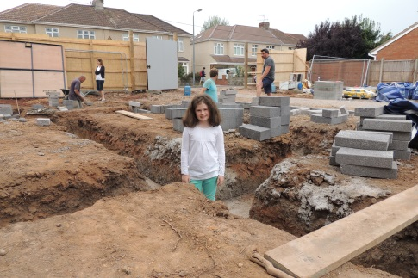Our budget was tight, having spent £160K on the plot we had £142K remaining to build a 142sqm house, allowing for £1K/sqm. Despite experienced advice from Buildstore., costs were not always as predicted and we finished some £23.5K over budget; that and an arrears-based funding mechanism forced a consistent cash-flow challenge solved only by the tolerance of First Direct and close friends, and some clench-teethed acceptance by contractors.

What went well?

* The digging and installation of the foundations went without a hitch
* Installation of the underfloor heating pipes by us

Figure 5: Going down before up

* 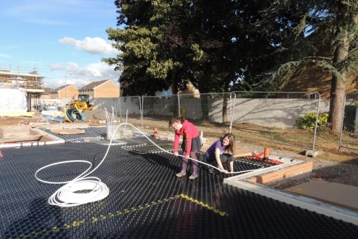Erection of the Timberframe took just 10 days, from arrival on a single lorry to completion of the roof structure and in almost unending torrential rain
* Installation of the main bulk of the windows
* Fitting of the steel roof
* External and internal carpentry and fitting of the external renderboard system, which sadly is hidden behinds wall coverings

Figure 6: Laying underfloor heating pipes

* 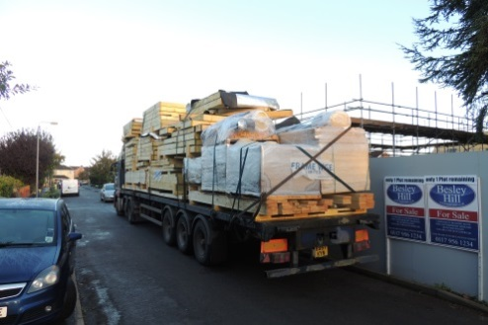The plastering was finished to an extremely high standard
* The precision of the electrical installations was aided by a laser
* The installation of additional thermal mass and acoustic isolating ‘screedboard’ floorboards to the upstairs floors

Figure 7: The House arrives

* The installation of the MVHR system by us
* The rock-music and beer fuelled painting party
* Our ability to keep going despite some seemingly intractable funding issues

What could have gone better?

* 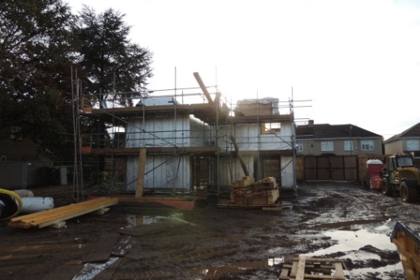The build of the structure took place Sep 13 - Jan 14 during the longest period of endless rainfall in living memory, causing all sorts of problems on site and, in particular, damaging the render. It is likely that the render damage will not be rectified until after we have moved in.
* 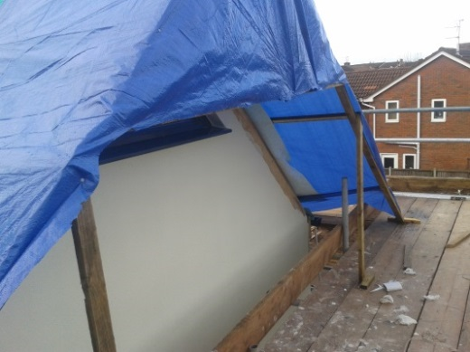We selected a new range of windows from Rationel, but this production line hit problems shortly after we ordered and would have delayed by at least 6 weeks had we not taken action. We re-selected an older design but had a triple-glazed unit added – this restored the delivery schedule and also came in at a welcome £2K cheaper. The older design windows have slightly lower heat-retention capability.

Figure : The Somme

* The Timberframe Company made some measurement errors, including: missing that there was a tall window that ran in one piece from kitchen to a bedroom; making the stairs 50mm too wide (see if you can see where the stairs are bedded into the wall); and making all the doorways 100mm too tall. This resulted in additional costs to us, although we did negotiate some quid pro quo.

Figure 8: One of the protective 'render tents'

* Installation of the very expensive but impressive Centor bifold door that took multiple visits over 4 months and for which the bill grew by 40%

Energy Specifications

* Thermal Insulation ‘U values[[1]](#footnote-1)’:
  + Walls 0.15
  + Roof 0.17
  + Floor 0.17
  + Windows 0.96 (average)
* Air change rate 4.9M3/M2/h[[2]](#footnote-2)
* PV generation 4Kw(peak) driving immersion heater into thermal store
* Thermal store[[3]](#footnote-3) 170L buffer only and no stored domestic hot water- loses 0.3-degC/hr at 85-degC
* Heat recovery[[4]](#footnote-4) 95% efficient
* Solar gain[[5]](#footnote-5)
* Lights All low energy, either LED or CFL, many in low usage areas on proximity sensors
* Back-up heat 2Kw electric fire in living room (mainly for fire effect) and 36Kw conventional condensing gas boiler
* Heating control Heatmiser system
* Cooking All electric, oven and inductive hob
* Extraction Kitchen recirculation only, air removed by MVHR which can be boosted in kitchen and all bathrooms

Other Specifications

* Built in 5.1 and hifi stereo wiring
* Cat 6E cabling and DTV to all living rooms and bedrooms
* Server system fitted for interaction through Cat 6E cabling – smart TVs
* Sky TV cabled to living rooms
* BT sockets collocated with Sky TV outlets for interactive services
* Four channel CCTV, 2 internal and 2 external cameras with DVR

Suppliers



Underfloor insulation system

[Frame Wise Ltd](http://www.framewiseltd.co.uk/)

Timerframe

[rationel](http://www.rationel.co.uk/professionals/)[Centor - Live beautifully](http://www.centor.com/uk/)

Windows

[http://www.wundafloorheating.co.uk/img/logo.png](http://www.wundafloorheating.co.uk/)

UFH

[](http://www.nuaire.co.uk/)

MVHR

[](http://www.ssab.com/en/Brands/Prelaq/)

Steel roof

[logo](http://www.gledhill.net/default.asp)

Thermal Store

[](http://www.rainclear.co.uk/)

Rainwater

[](http://www.cellecta.co.uk/)

[](http://www.econicboard.com/)First floor thermal mass

R

R

Duncryne_logoRenderboard

[PAREX LTD - Specialist materials for civil engineering, infrastructure and construction](http://www.parex.co.uk/)Render



Photovoltaic (solar) panels

**[](http://www.buildstore.co.uk/)**

Advice

[](http://www.trade-point.co.uk/)

General stuff

1. A measure of how quickly heat moves through a building element, such as a wall [↑](#footnote-ref-1)
2. A measure of the air leakage rate – we were required to get under 5 [↑](#footnote-ref-2)
3. A cylinder to store heat in water – provide domestic hot water and buffer store for the wet heating [↑](#footnote-ref-3)
4. Exchange of heat from outgoing stale air to incoming fresh [↑](#footnote-ref-4)
5. A measure of how well the building captures incident sunlight [↑](#footnote-ref-5)